# KHLOUD

About Me

**•Bachelor of computer and information, BSc. Of in**

**bioinformatics systems,**

**Faculty of computer and information, Assiut**

**University, June 2023**

**I am looking foward for my first work**

**01008283472**

**lodashokry64@gmail.com**

**26 Abu Bakr El Seddik St. Feryal**

**Assiut Governorate**

## LANGUAGE

**Arabic.**

**English.**

# SHOKRY

INTERNSHIP

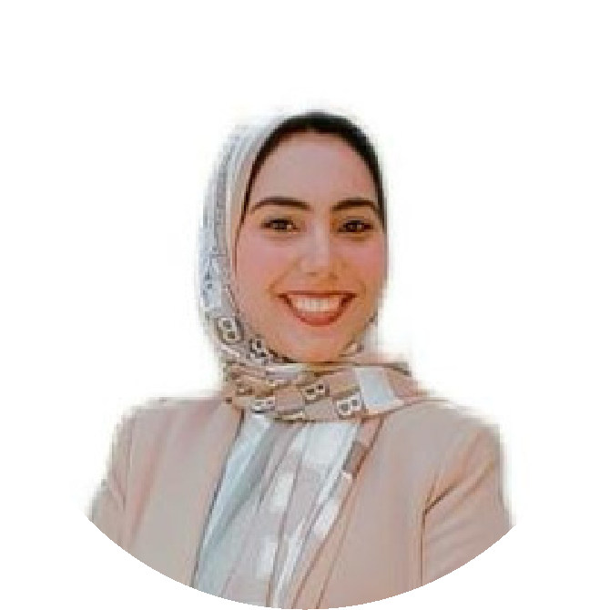

## Wazeefa Tech initiative under the supervision of

**ITI(full stack development)**

### TECHNICAL SKILLS

**Front (HTML,CSS,JavaScript). Microsoft (Word, Excel, Power point).**

### EDUCATION

**FACULTY OF COMPUTER AND**

**INFORMATION, ASSIUT UNIVERSITY, JUNE**

#### 2023

**•GRADE: VERY GOOD (B+) WITH HONOR, GPA (3.44).**

**•GRADUATION RESEARCH PROJECT**

**:SVISION DEEP LEARNING APPROACH TO**

**IDENTIFEY COMPLEX STRUCTURE**

**VARIATION**

### PERSONAL SKILLS

* **The measures of career safety andethics.**
* **Teamwork spirit and co-operation.**
* **Hard worker under stress.**